**Project Proposal-Phase I**

**Carinthia University of Applied Sciences  
Engineering and IT**

**Systems Engineering/Mechanical Engineering**

**Vision Control**

**Applying Supervised Learning in a Classic Control Scenario**

by

**Laurenz Hundgeburth**

1720527051

Laurenz.Hundgeburth@edu.fh-kaernten.ac.at

|  |  |
| --- | --- |
| Supervisors: | FH-Prof. Dipl.-Ing. Dr. Wolfgang Werth,  w.werth@fh-kaernten.at |
| In cooperation with Carinthia University of Applied Sciences | Heinz-Peter Liechtenecker, BSc MSc,  h.liechtenecker@fh-kaernten.at |
|  | Villach, 19.06.2019 |

1. **Introduction**

This project is about applying supervised learning in a classic control scenario.

During the last decade machine learning algorithms have become increasingly popular, as they have more than once proven unbeknownst performance in many difficult tasks including computer vision and speech recognition. Though they have been known and studied in the late 60’s, their performance and capabilities were for a long time limited by slow computers and a general rarity of larger data sets. Both of which no longer play a role due to an ever-increasing ratio between computing power per price and a general tendency towards openness, when it comes to data and its accessibility.

To acquaint with this new approach and leverage some of its possibilities in a well-studied and practiced field here at the Carinthia University of Applied Sciences we plan to design a vison sensor that can be used and tested in control applications. This will be accomplished in three major steps, including the acquisition of a proper data-set, the training of a convolutional neural network and some unit integration tests, where we battle-test our sensor with hardware under different circumstances. We decided to measure the rotation angle of a motor, as we have all the required hardware available at the University.

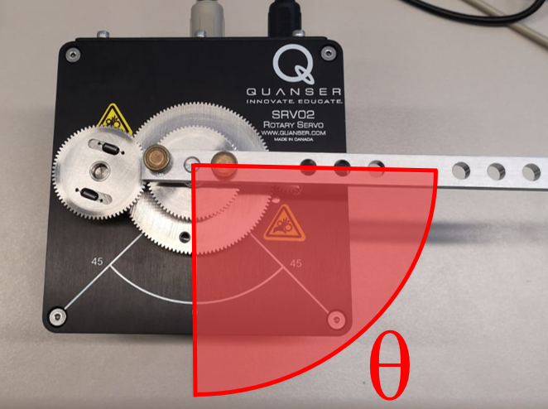

1. **Definition of the problem**

The Problem consists mainly in dealing with complex, high-dimensional data like images, their analysis and processing and further with the transmission of the extracted information over a distributed system. Such a setup includes the following components:

* sensor unit for data acquisition
* personal computer for data processing
* microcontroller for control tasks
* a mechanical system to control

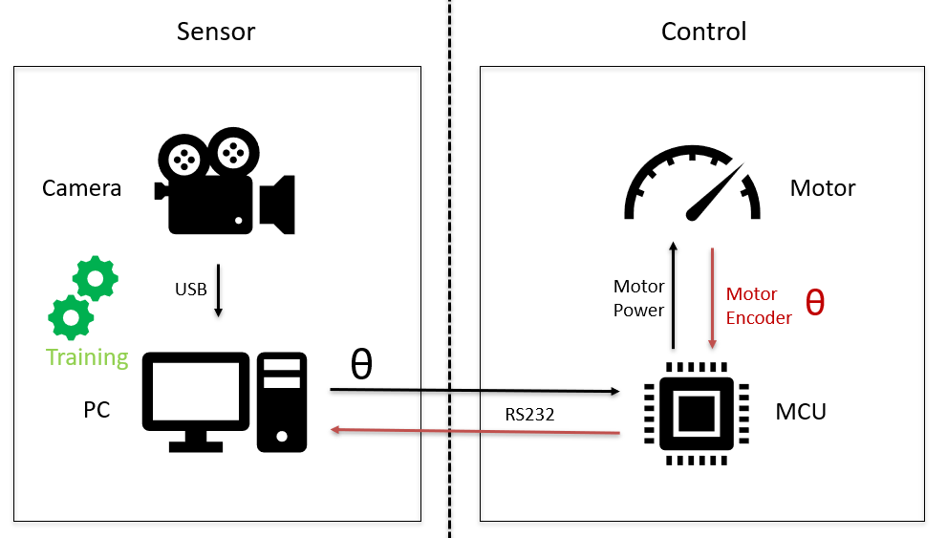

The personal computer is rather uncommon in a control setup, because most of the needed task can also be done on the microcontroller.

The main difference lies in the disproportionally larger computing power of a pc compared to a small microcontroller. This additional power is needed because we work with large and complex input data which require a substantial amount of calculations to process the data, which would not be feasible on a small microcontroller.

Another important part of our work will be to test and benchmark our sensor system. Important metrics to evaluate will be the accuracy, dependability, performance and its robustness against noise.

It is important to mention here that we do not expect our solution to be superior to other sensor solutions for control systems. Our main aim is to test and explore a novel approach.

1. **Method or proposed solution**

We plan to use a convolutional neural network which will be running on the personal computer. This network is responsible of extracting useful information out of the images to use them for control. Neural networks are machine learning algorithms that are not programmed in a traditional way. Instead of programming a lot of rules and expert knowledge into the machine, which can be very complicated and tedious for high dimensional data, the algorithm is shown a huge training set of images and learns the corresponding representations by itself. This programming model is called supervised learning and is very powerful because of its generalist nature. That basically means that if the network is sufficiently complex and you have enough training data, the domain in which this algorithm is applied is not important. Such an algorithm can be used in a variety of different fields like medicine, chemistry, music, art, it and in our case - control.

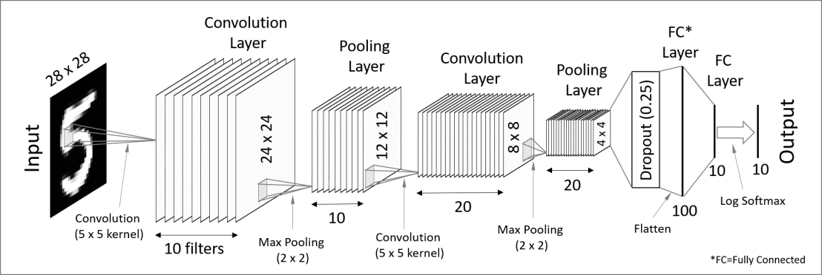

1. **Plan of work**

The first step (after initial research and project management discussions and decisions) is to test the hardware and the individual components. If we can not handle every single system on its own, then putting them together will be futile.

This step includes:

* Getting valid images from the camera.
* Programming a simple control loop on the microcontroller.
* Install all the dependencies and libraries on the computer and run some demos to ensure functionality.

The next step will then be the acquisition of a proper data set, which we need for training our network. This is the first time, when all the different components will be put together. The experimental setup needs to be thoroughly thought through because mistakes from this stage will be very hard to correct/compensate in later steps. Furthermore, any form of automation will greatly reduce the time needed for adjustments in the training set, which will only be known once training starts.

The next project phase will be dedicated to the training of the network. Ensuring that the network reaches acceptable accuracy and good performance will be vital in this step. Experts also call this step the “hyperparameter tuning step”, because one can adjust many settings and values of the network to optimize its performance.

The last step will then be to test the trained network and the overall sensor system, comprised of the camera and the personal computer, in a classic control loop. Even if the trained network reached acceptable accuracy in the last step, it will be interesting to see how reliable this accuracy is reached under different circumstances.

1. **Project milestones**

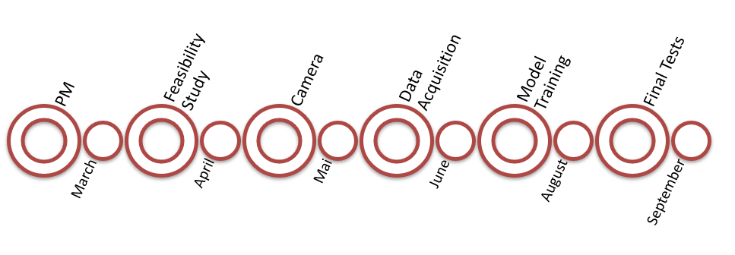

The feasibility study consists of a complete training of a convolutional neural network with one of the many free available data sets from the web. This step would take an expert probably only a few hours or days to complete, but as we are new to the field, we planned enough time to acquaint with al the tools and the workflows.

The camera and data acquisition phase are closely related. Both will not include any machine learning thus taking less time to work into the topic. However, these two steps are very labor intensive and therefore need at least two months to complete.

The training of the model then also takes at least two months because we expect to do a lot of trial and error.

Though the projects must be submitted in December, we plan to finish in October to have at least some room for experiments and further research.

1. **Facilities**

* USB-Camera
* Tripod
* PC or Laptop
* Microcontroller Development Board
* Motor Driver IC
* Servo-Motor

1. **Personal**

**Gregor Fritz** will mainly be responsible for managing all the different hardware components, their interconnectivity and the configuration and installation of the Camera. He will also play a big role in developing a proper experimental setup for the data acquisition.

**Laurenz Hundgeburth** will be focusing on training the network properly and ensure its accuracy and reliability.

We as a team do consider excessive project management as rather useless. Our strategy is to start with a very small and doable goal with roam to improve. Once good decisions have been made we plan to keep the pressure up.

It is also very crucial to constantly question the validity of the decisions to adapt quickly to newly obtained knowledge.

1. **Budget**

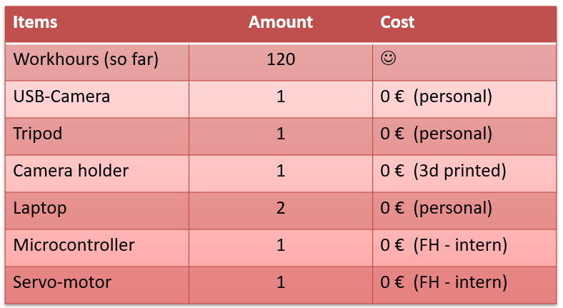

1. **Problem analysis**

The main challenge will be to get an appropriate training set and to do training right. The problem here is our missing expertise and we expect to learn a lot during this project. However, we are positive, that if we keep focusing on one problem at a time, we will finish on time.

1. **Conclusion**

To sum up, the goal of this work is to build and train a visual sensor with a convolutional neural network which can be used in control applications. This approach is novel in a way that it uses machine learning to build a very custom and affordable sensor. We have prepared ourselves well for this task and are very positive that the sensor will show great performance, both in accuracy and in reliability. We also think that machine learning should have a stable place in a control engineers’ repertoire and are eager to demonstrate its capabilities.

1. **Bibliography**
2. **Appendixes**

**Coursera: Machine Learning Stanford University**

<https://www.coursera.org/learn/machine-learning>

**Coursera: Deep Learning Specialization Andrew Ng**

<https://www.coursera.org/specializations/deep-learning>